Symbol Sense: One-Stop Solution to Decode Math Notation
Resa Kemal Saharso, University of Edinburgh, s2879727@ed.ac.uk
Gregorius Dimas Baskara, University of Edinburgh, s2703107@ed.ac.uk
Rahmah Khoirussyifa Nurdini, University of Edinburgh, s2820905@ed.ac.uk
Nabillah Octarani, University of Edinburgh, s2744730@ed.ac.uk

Abstract
The use of unfamiliar mathematical notation tends to negatively impact Computer Science students' understanding of the overall course material. By developing a deeper comprehension of mathematical notation, students can enhance their academic progress, both in coursework and research activities.
Symbol Sense is proposed to address this problem. This tool assists students in understanding mathematical notations and equations by explaining variables, their relationships, and the steps toward the final state of the equation. Students can also explore beyond the notation by asking follow-up questions, requesting mock problems, or obtaining relevant references such as books and papers for further study. Implemented as a web application, Symbol Sense allows students to upload images of equations for automatic analysis and explanation, supported by a chat interface for extended inquiry.
However, this tool also poses the risk of inaccuracy and potential misuse. To address this risk, this tool should include confidence indicators and clear ethical guidelines to ensure it remains a supportive learning aid rather than a shortcut.

1. Introduction / Problem Statement
Imagine being a Computer Science student trying to follow a math-intensive lecture, but every time a mathematical notation appears on the course materials, the student starts getting very frustrated with the course. At first, the students try to keep up, but as the formulas get more complex, the meaning behind them starts to fade, and soon the entire topic feels out of reach. This struggle with mathematical notation can create a cascade effect of inability to interpret symbols, which leads to poor comprehension of the subject. Recent research found that over 50% of students’ errors were linked to problematic conceptions of mathematical notation [1]. Hence, it suggests the barrier is not lack of capability, but an inability to decode mathematical notations.
A study on students’ algebraic expertise has also shown that when students develop fluency with mathematical notation, their overall mathematical comprehension and performance improve significantly [2]. Beyond coursework, this deeper mathematical notation understanding will also support students in their academic journey, especially when writing research papers. While this problem is highly relevant for Computer Science students, those in other disciplines, such as social sciences, also find it relevant, as they increasingly rely on analytical methods and mathematical reasoning in their fields.

2. Proposed Solution
With Symbol Sense, our solution is to assist students in understanding mathematical notations and equations by explaining the variables involved, rules that define interactions of variables, and the steps required to achieve the final state of the equation. This streamlined process reduces the effort students need to take to grasp complex mathematical notations, allowing them to focus more on learning rather than struggling with interpretation. Symbol Sense can also help students explore beyond the notation by asking follow-up questions or requesting a mock question for further understanding. Additionally, Symbol Sense can also recommend relevant resources to students such as books or papers related to the current notation. To ensure that the suggested materials are verified and valid, teachers can contribute to this list of resources.
We have designed a web application that can accept images (e.g. screenshot of lecture slides or literature) in which students can upload the content they want to be explained. The application will then break down and explain the notations and equations (if any) in the image, including any additional context alongside it. The following image is a screenshot of the Symbol Sense prototype, and we have also prepared a demo video of the application in this link (University of Edinburgh email required).
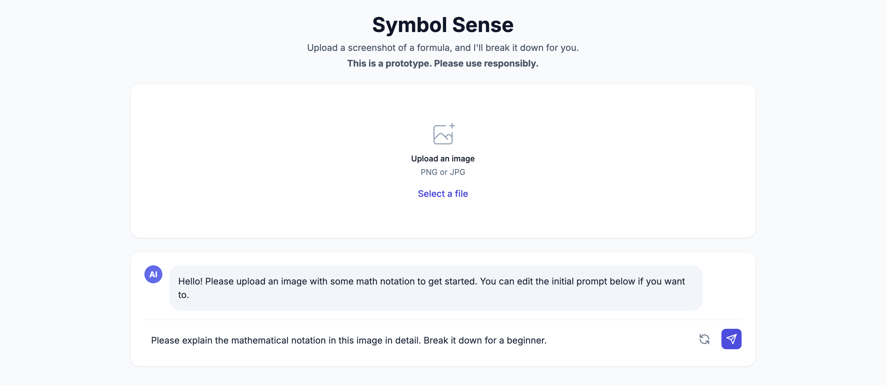

3. Implications & Ethical Considerations
The proposed tool may have various implications—both positive and negative—as well as additional ethical considerations. Within the broader education system, this tool could assist students across disciplines in understanding mathematical concepts, particularly complex equations with uncommon notations. It could be especially helpful for students without a prior background in mathematics, enabling them to grasp the formulas they encounter in their lectures. By developing a sufficient understanding of these notations, students can gain a clearer grasp of the broader context of the course. Therefore, this tool has the potential to benefit all students whose courses involve mathematical notations, especially those in Computer Science.
Despite its benefits, the use of this tool also introduces a significant risk related to the accuracy of the model’s explanations. In better cases, the model might produce explanations that are irrelevant to the notation queried by students. In such cases, students should be able to recognize that the model is confused and understand that they shouldn’t trust its output. However, in worse-case scenarios, the model may generate explanations that appear relevant and trustworthy but actually misrepresent the notation. This kind of error could mislead students into developing a false understanding of the notation and the course material. Additionally, the usage of proprietary models has a potential risk of leaking confidential information contained in the uploaded media.
This tool may also raise certain ethical considerations. For instance, in tasks or coursework where students are expected to derive a particular formula, some may misuse the tool as a shortcut to complete their work with minimal effort. Such misuse can be particularly harmful when the derivation process is essential for developing a proper understanding of the material. It may also create unfairness between students who complete their work independently and those who rely on the tool to gain an advantage.
To avoid negative implications when adopted broadly, the model should incorporate reliable confidence metrics. If it is not confident in the explanations it generates, it should instead indicate that it has failed to fully understand the notation. In this way, the model would avoid misleading students, even if its output is not particularly helpful in explaining the notation. To address some of these problems, we propose a solution to use open-source models to prevent data leakage, hosting the model in appropriate environments (e.g. university network) to secure access, as well as to thoroughly analyze the model’s capabilities to prevent hallucinations and ensure the generated summaries can be trusted. However, from an ethical standpoint, human intervention would still be necessary to establish rules and guidelines that prevent students from abusing the tool in their tasks or coursework.

References
[1] Chin, K. E., & Pierce, R. (2019). University Students’ Conceptions of Mathematical Symbols and Expressions. EURASIA Journal of Mathematics, Science and Technology Education, 15(9). https://doi.org/10.29333/ejmste/103736
[2] Bokhove, C., & Drijvers, P. (2012). Effects of a digital intervention on the development of algebraic expertise. Computers & Education, 58(1), 197–208. https://doi.org/10.1016/j.compedu.2011.08.010

